5-Whys Guide & Template

The 5-Whys is a simple brainstorming tool that can help teams identify the root cause(s) of a problem. Once a general problem has been recognized from your data. You can ask “why” questions to drill down to the root causes. Asking the 5-Whys allows teams to move beyond obvious answers and reflect on less obvious explanations or causes.
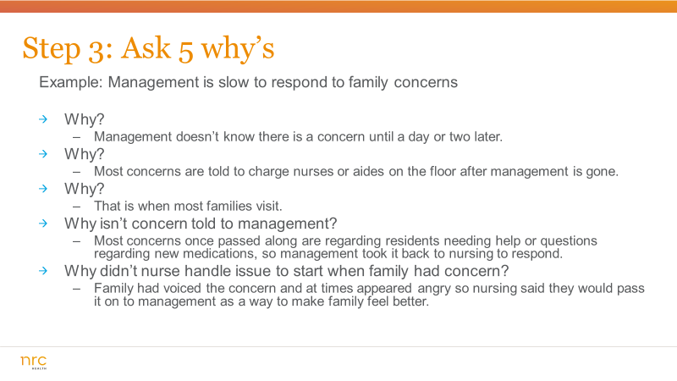
Step-by-step instructions

1. State the problem you have identified as a strategic problem to work on.

2. Start asking “why” related to the problem. Like an inquisitive toddler, keep asking why in response to each suggested cause.

3. Ask as many whys as you need to get insight at a level that can be addressed (asking five times is typical). You will know you have reached your final „why‟ because it does not make logical sense to ask why again.

It is said that only by asking "Why?" five times successively, can you delve into a problem deeply enough to understand the ultimate root cause. By the time you get to the 4th or 5th why, you will likely be looking squarely at management practices (more than five whys may be required for complex problems).
[Grab your reader’s attention with a great quote from the document or use this space to emphasize a key point. To place this text box anywhere on the page, just drag it.]

1245 Q Street | Lincoln, NE 68508
P: 1 800 388 4264 | F: 1 402 475 9061
nrchealth.com

5-Whys Worksheet

Define the Problem:
You do not want to list 5 different reasons; you want to go deep on 1 reason.

Why is it happening?
Why is that?
Why is that?
Why is that?
Why is that?

a
1245 Q Street | Lincoln, NE 68508
P: 1 800 388 4264 | F: 1 402 475 9061
nrchealth.com
Multiple Solutions
Caution:
- If your last answer is something you can’t control, go back up to the previous answer on 1 reason
- Cannot because of a person

