Dear [name],

We are committed to providing excellent care and service. NRC Health,
an independent outside resource, has been commissioned to conduct a satisfaction survey of our [insert all that apply: residents, patients, participants, clients, families and other involved individuals]. We are asking for your assistance in completing the short survey, designed to give us feedback on levels of satisfaction with the care and service we provide.

Your input will help us in two very important ways. It will help us identify opportunities for improvement, as well as identify areas in which our staff has achieved excellence in the care and service they deliver.

Please watch your mail for this envelope!
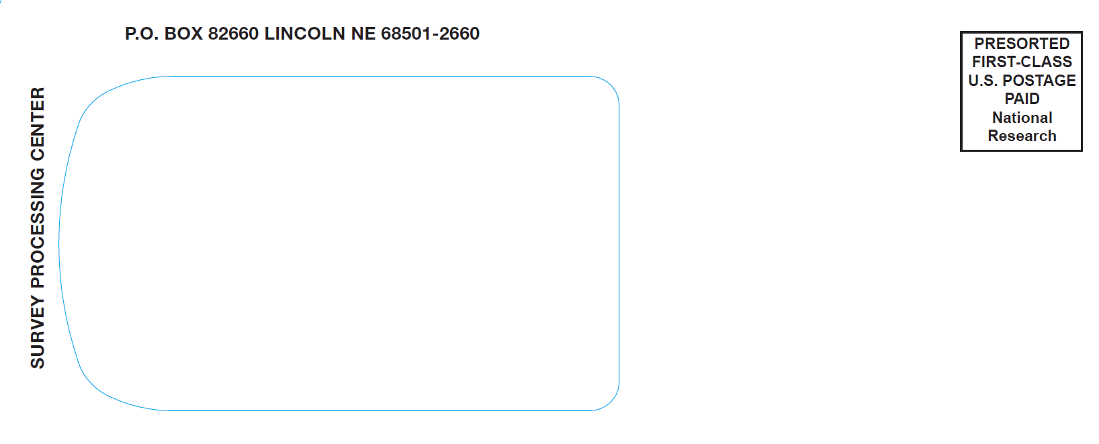
The envelope will contain a survey
from NRC Health.

IMPORTANT INFORMATION:
- It will take only a few minutes
of your time to complete the survey.
- Your responses are confidential. Surveys are processed by NRC Health and a summary report is prepared. This report does not include any information that can be linked to individual responses.
- There is a form for written comments. If you choose to submit comments, the form will be shared with us. It is not necessary for you to identify yourself on the survey or comment form.
We strive for excellence! Your time and participation are greatly appreciated. Your input is needed so we can continue to improve areas that are important to you.

Please complete the survey and return it to NRC Health in the postage-paid envelope provided. It is important that you return the survey by the due date. We appreciate your help! Thank you!

For more information about this survey, go to www.myinnerview.com/satisfaction

