To all employees,

We clearly recognize that the work you do is important. And, we recognize that job satisfaction directly impacts the quality of care and services our residents receive. You deserve the best possible work environment! To provide a work environment that meets your expectations, we need to know what is important to you — and where to make improvements.

As many of you know, we partner with NRC Health to conduct our employee satisfaction surveys. We value your feedback and want to achieve 100% participation from all employees.

NRC Health has been commissioned as an independent outside resource to conduct a satisfaction survey of our employees. All responses will be processed, compiled and shared with us in report form — employee names will not be included. This report does not include any information that can be linked to individual responses.

In addition to the short survey, you will have the opportunity to submit narrative comments. These comments will be shared with us exactly as you enter them during the survey.
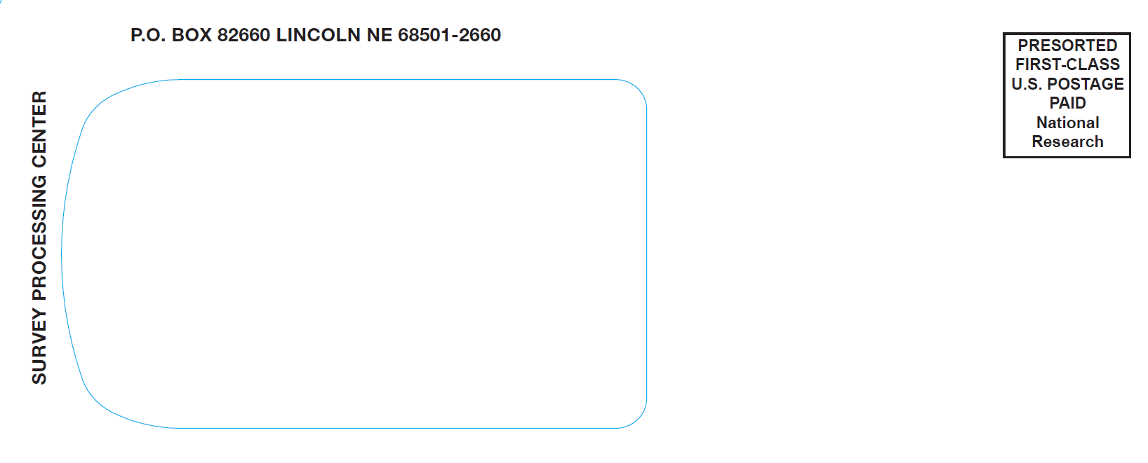
Watch your mail for this envelope!

The envelope will contain the survey
from NRC Health

Please give us your honest feedback!

Your responses are confidential — your identity will not be known unless you choose to identify yourself in a comment. If you have any questions at all, please feel free to contact NRC Health Client Services at (800) 601-3884.

A high participation rate is important to the success of this survey.

Please use the survey to give us your honest feedback. We appreciate your help.

