NRC Health Product Update – November 5, 2018

We are pleased to announce several updates made to our NRC Health platform for Real-time Feedback on November 5, 2018. **Learn more** below about what’s new, improved, or fixed by clicking to expand each feature to view details. And, get a sneak-peak at what’s coming up next.

# What’s New.

New Actions and Documentation TO Better Manage Service Alerts

Close alerts, open alerts, assign alert ownership, and document actions taken to resolve alerts with new alert management features.

How it Works

* Go to **Feedback Management**
* Click on **Actions**

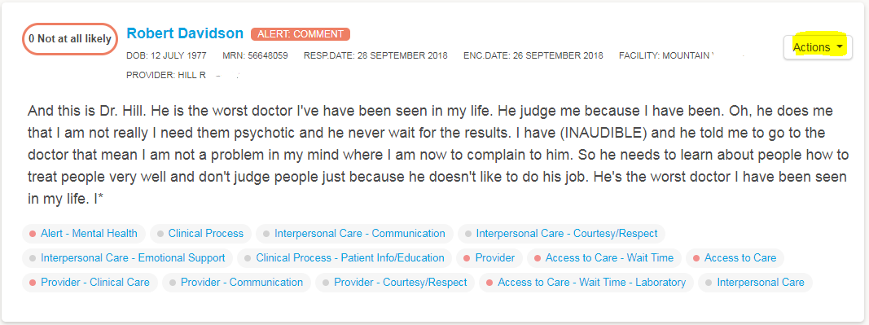

* Click on **Customer Name, Click on Actions, and Log Call**

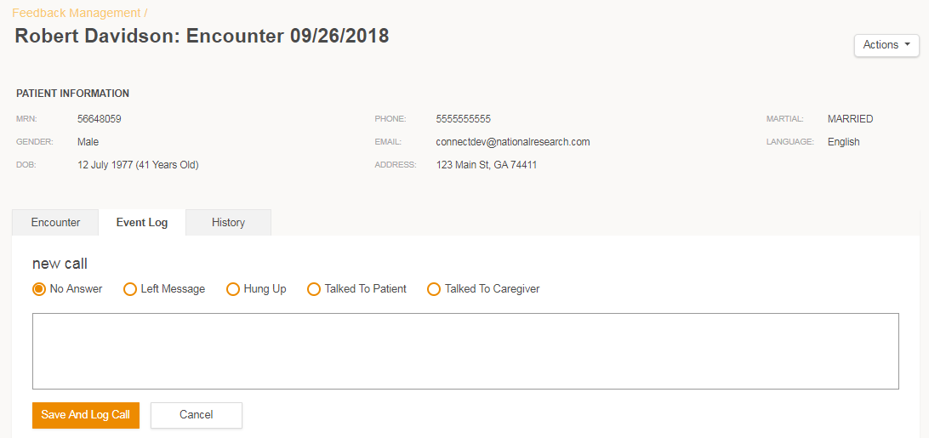

see how a customer answered all questions

To provide you with more insights to a customer’s experience that triggered a service alert, you can now view how they responded to every question.

How it Works

* Go to **Feedback Management**
* Select **customer name**, scroll down to view responses for closed-ended questions

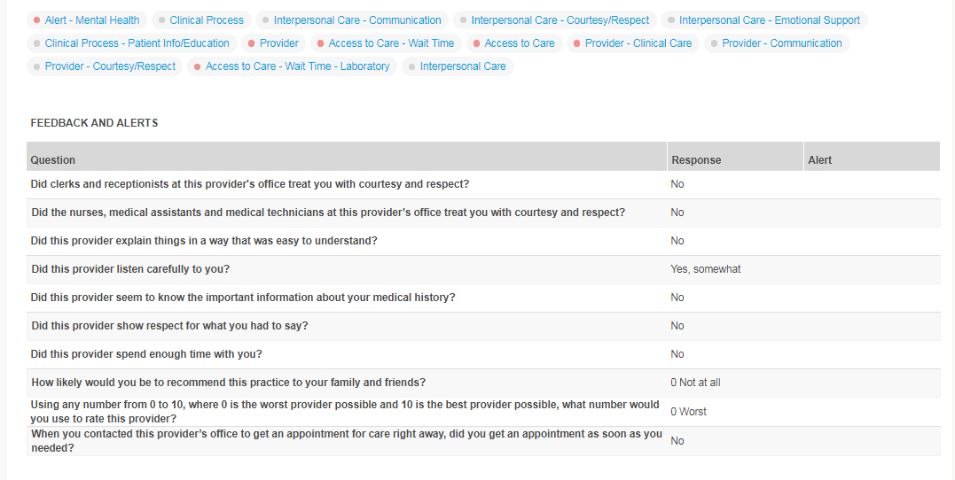

view all customer outreach and Service Recovery activity

For each customer encounter, you can see all outreach activity, as well as, any related follow-up activities by front-line staff to resolve alerts.

How it Works

* Go to **Feedback Management Report**
* Select **Customer Name**
* Click on the **Event Log** tab

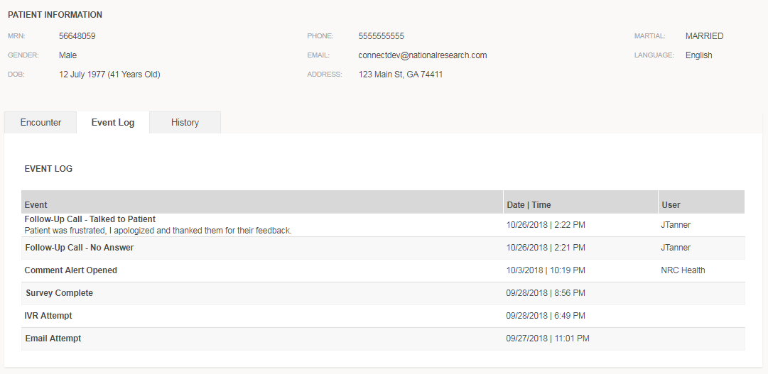

Easily View past vists and Feedback FOR INDIVIDUAL customers

When resolving customer alerts, you can now quickly view any historical customer feedback, service alerts, and actions taken to resolve those alerts within a new history tab.

How it Works

* Go to **Feedback Management Report**
* Click **Customer Name**
* Click on the **History** tab
* Drill through on encounter date to bring up past responses and event log

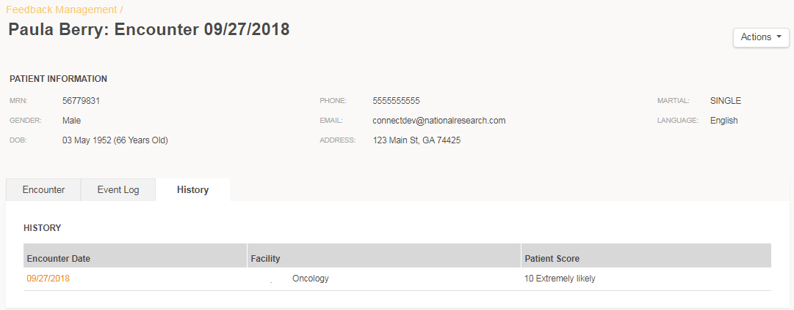

Calculate ROI for Customers REturning With alerts

A single dashboard to trend percent of customers with alerts, as well as, highlight drivers of alerts and rank your health system facilities with highest/lowest volume of alerts. Use the Service Recovery Calculator to estimate the value of your service recovery efforts.

How it Works

* Select **Alert Dashboard**
* Set assumptions of **Service Recovery Calculator**

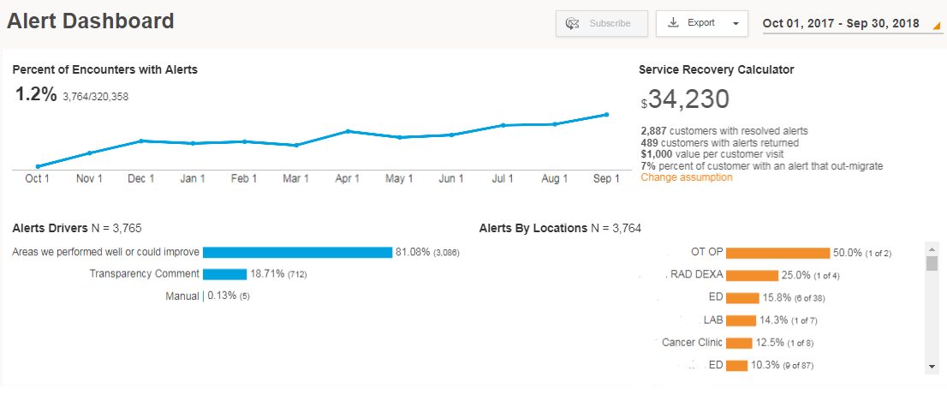

Track Alert Volume and Resolution by location

A simple table to show the number of customers reached, the percent of responses that trigger alerts, how that compares to previous time periods, the percent of alerts resolved, and which questions are triggering alerts.

How it Works

* Select **Alert Volume** from menu of reports.

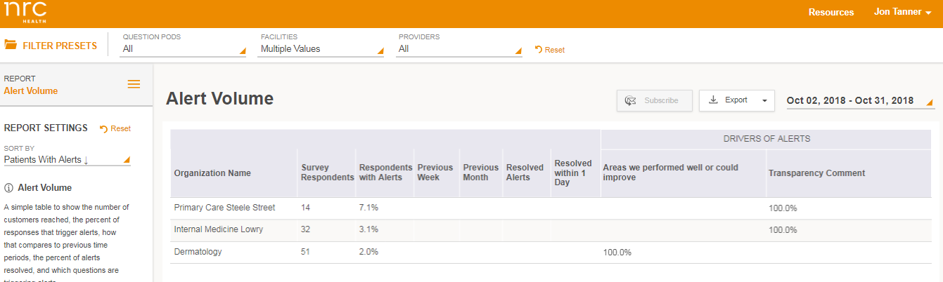

Easily view notes from service recovery process

For any location and timeframe, you can view all documentation posted by your staff during their service recovery efforts.

How it Works

* Select **Alert Notes** from menu

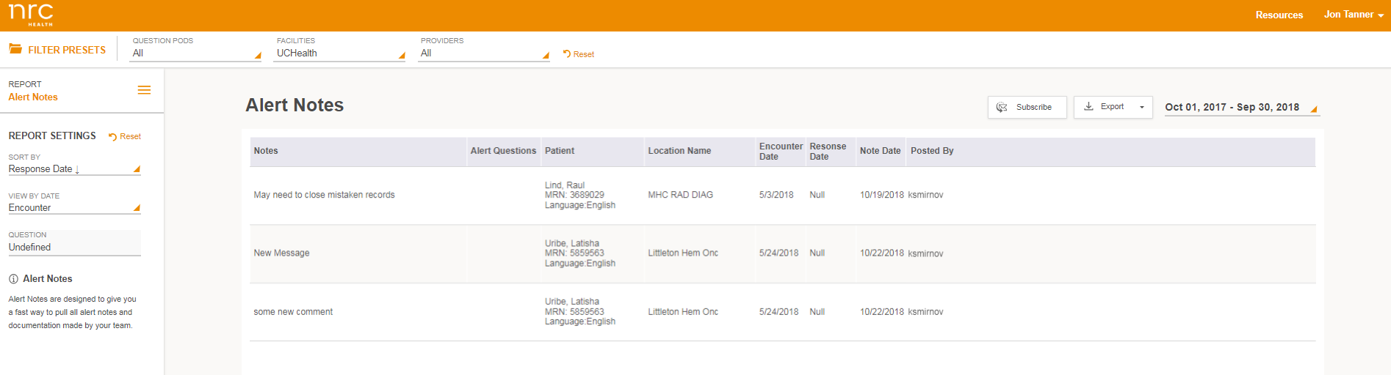

trigger service alerts from closed-ended question RESPONSEs

Historically, Service Alerts trigger based on open-ended comments from Real-time Feedback using Natural Language Processing (NLP). Now, you have the option to also trigger Service Alerts based on response options to closed-end questions.

How it Works

* Contact your Project Specialist to learn more

# What’s Improved.

FEEDBACK MAnagement centralizes all feedback and service recovery

Previously, you navigated to separate locations to view all customer feedback and service alerts. Now, both are located within Feedback Management as your centralized location to read all customer feedback and perform service recovery.

How it Works

* Go to **Feedback Management**

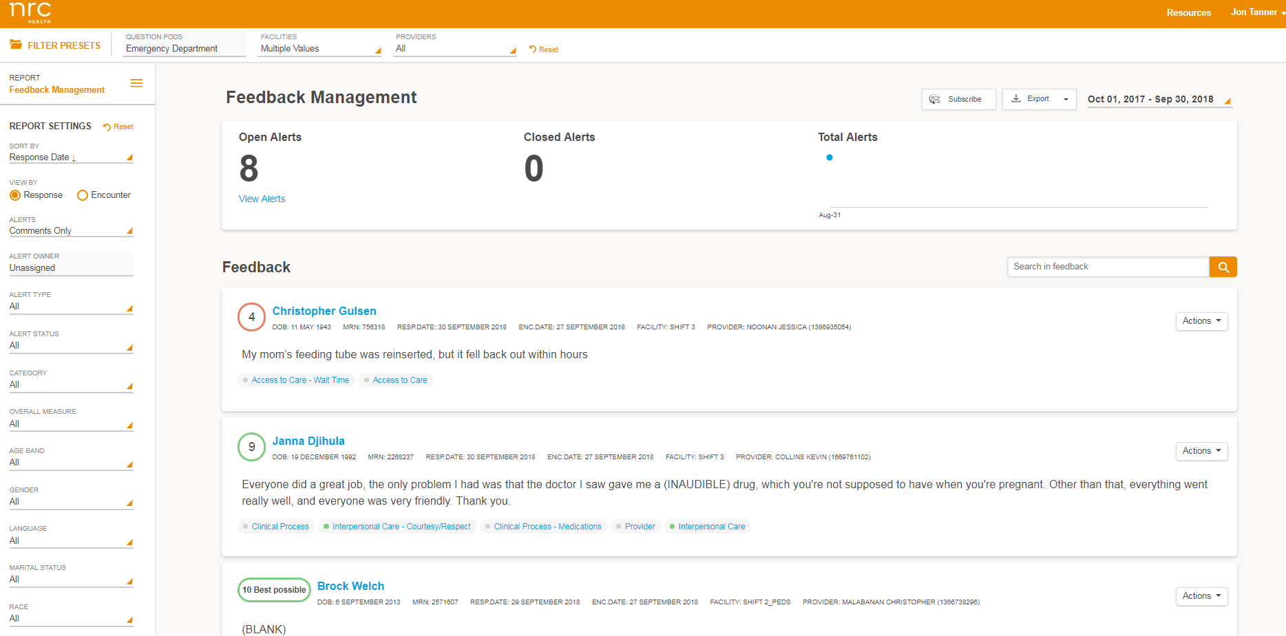

PDF EXPORT AND SUBSCRIPTION FOR FEEDBACK MANAGEMENT

Based on popular demand the Feedback Management Report now has option to export to PDF, as well as, ability to subscribe to the report for delivery to your inbox. Please note that there is a 1000 comment limit on PDF exports.

New Default Time PEriods Added to FEedback Management

The Feedback Management Report now has option to filter the report by “Today”, “Yesterday”, and “Last 7 Days”.

Ability for respondent to notify NRC health about wrong contact information

IVR and Email outreach has been updated to allow respondents to notify us that we have the wrong contact information for the outreach.

How it Works

* Respondent identifies that we have reached the wrong number or address. NRC Health cancels any pending outreach attempts
* NRC Health does not place that phone number or email on the Do Not Contact list

# What’s Fixed.

View all available CMS Classification and specialty provider Benchmarks

Previously you were only able to access CMS Classification and Specialty benchmarks for the Classifications and Specialties that were relevant to the NPI’s sent to NRC Health. For example, if you weren’t sending NRC Health any family medicine NPI’s then you would not have access to the family medicine benchmark. Now all benchmarks are available regardless of the specific NPI’s you have sent to NRC Health.

ability to Create new Users with Same NAme of an existing user

Admin users would receive an error message when creating new users that had the same first and last name as another existing user. Now, Admin users can create new users with same name if the email address is unique.

both WEB and IVR SURVEYS will expire 2 weeks after send date

Web surveys are now set to expire with the same rule as IVR surveys - two weeks after send date. This will allow for you to provide “closed” reports to leadership (reports that will not have any additional responses added). Historically, NRC Health received more than 99% of all email responses within 2 weeks of send date, so this should not noticeably impact response rates, or response volumes.

# What’s Coming Up.

view your hCAHPS data by month and by unit

The HCAHPS report will be expanded to provide views by month, units, and the ability to compare to CMS benchmarks.

pROVIDER SCORECARD Data Label Updates

The Provider Scorecard will be updated to more clearly display calendar quarter versus fiscal quarter. And, the Provider Scorecard header will include both the start and end date represented within the data.

view Your PERCENTILE RANKS for all questions in a central location

Percentile Rankings will available in two reports - the Score Summary Report and the Benchmark Report - so, you can view percentile ranks of all questions in a central location.

SET improvement GOALS for locations, service lines, or units

Currently, improvement goals can be set organization-wide and for individual providers. Soon, you will have ability to set goals for your unique locations, service lines, or units.